Mini Project Synopsis

18CSE21 - IOT

**Home Automation for aged and differently able’d, using Raspberry Pi**

**Team Members:**

Abdeali – 4NM19CS002

Akash L M – 4NM19CS012

Ashwamedh Arote – 4NM19CS031

**Semester :** 6

**Section :** A

**Submitted to:** Dr. Venugopala P.S

**ABSTRACT:**

This Project is used for controlling the Electronic Devices by the use of Internet. Because Internet plays an important role in day to day life. The Focus of this project is to supply the easy access of devices to the people, this systems contains some sensors, Detectors which can be embedded with the Raspberry pi along with Aurduino. It acts like a server and many updates will be stored in Database. We can use by Python or Android or web Applications. This website may contain Login System and also UI. The objective of our system is to take care of several domestic systems that may normally be difficult for those who are handicap or elderly to take care of.

**PROBLEM STATEMENT:**

The focus of our project is on helping users to operate home appliances with their own smart phones and to help elderly or handicapped people live a more independent life as long as possible. The proposed idea will allow a user with any android enabled device to run a piece of downloadable software on a smart phones. This application will allow the user to control a device that is connected to any home appliance that is Pi enabled. The focus of this application will be a fan controlled and a light control system. Sensors will be connected to the home appliances with Pi so that they can be monitored and controlled. The Client could also check the status of the outside light and turn on and off the light without the need to get out of bed. These devices would also benefit users with limited mobility that may have a difficult time getting to or even reaching their light switch.

**PROPOSED METHODOLOGY:**

A Wi-Fi based Wireless Sensor Network(WSN) is designed only for the purpose of monitoring and controlling environmental, safety and electrical parameters of a smart interconnected home. The user can exercise seamless control over the devices in a smart home via the Android application based Graphical User Interface (GUI) on a Smartphone. It provides facility to have control over a wide range of home appliances and ensure securities. It also permits open access to a wide range of control of digital services.

**Rough idea or Blue Print of project to be implemented:**

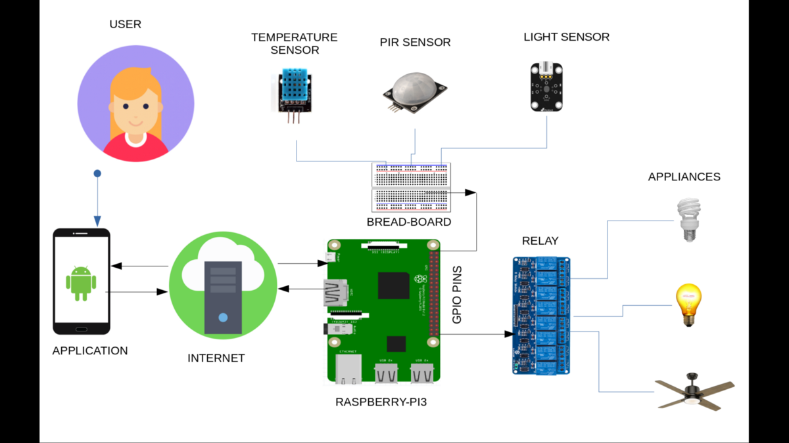

**OUTCOME:**

The future idea is to design a user friendly application and model to end users. And implement a safe system to control a wide variety of home appliances, especially for the aged and differently able’d ones.